Behavior

We follow the Multi-Tiered System of
Support (MTSS) for our school-wide behavior expectations. This includes expecting your child to Be Respectful, Be Responsible, Be safe, and Be a Learner.

Occasionally, you might receive a “Behavior Incident Form” regarding your child’s behavior. This can be perceived as a negative report; however, it’s actually a means of communication between school and home. It informs you of a situation in which an appropriate choice has not been made. Although the situation has been addressed at school, your support and reinforcement at home is appreciated.
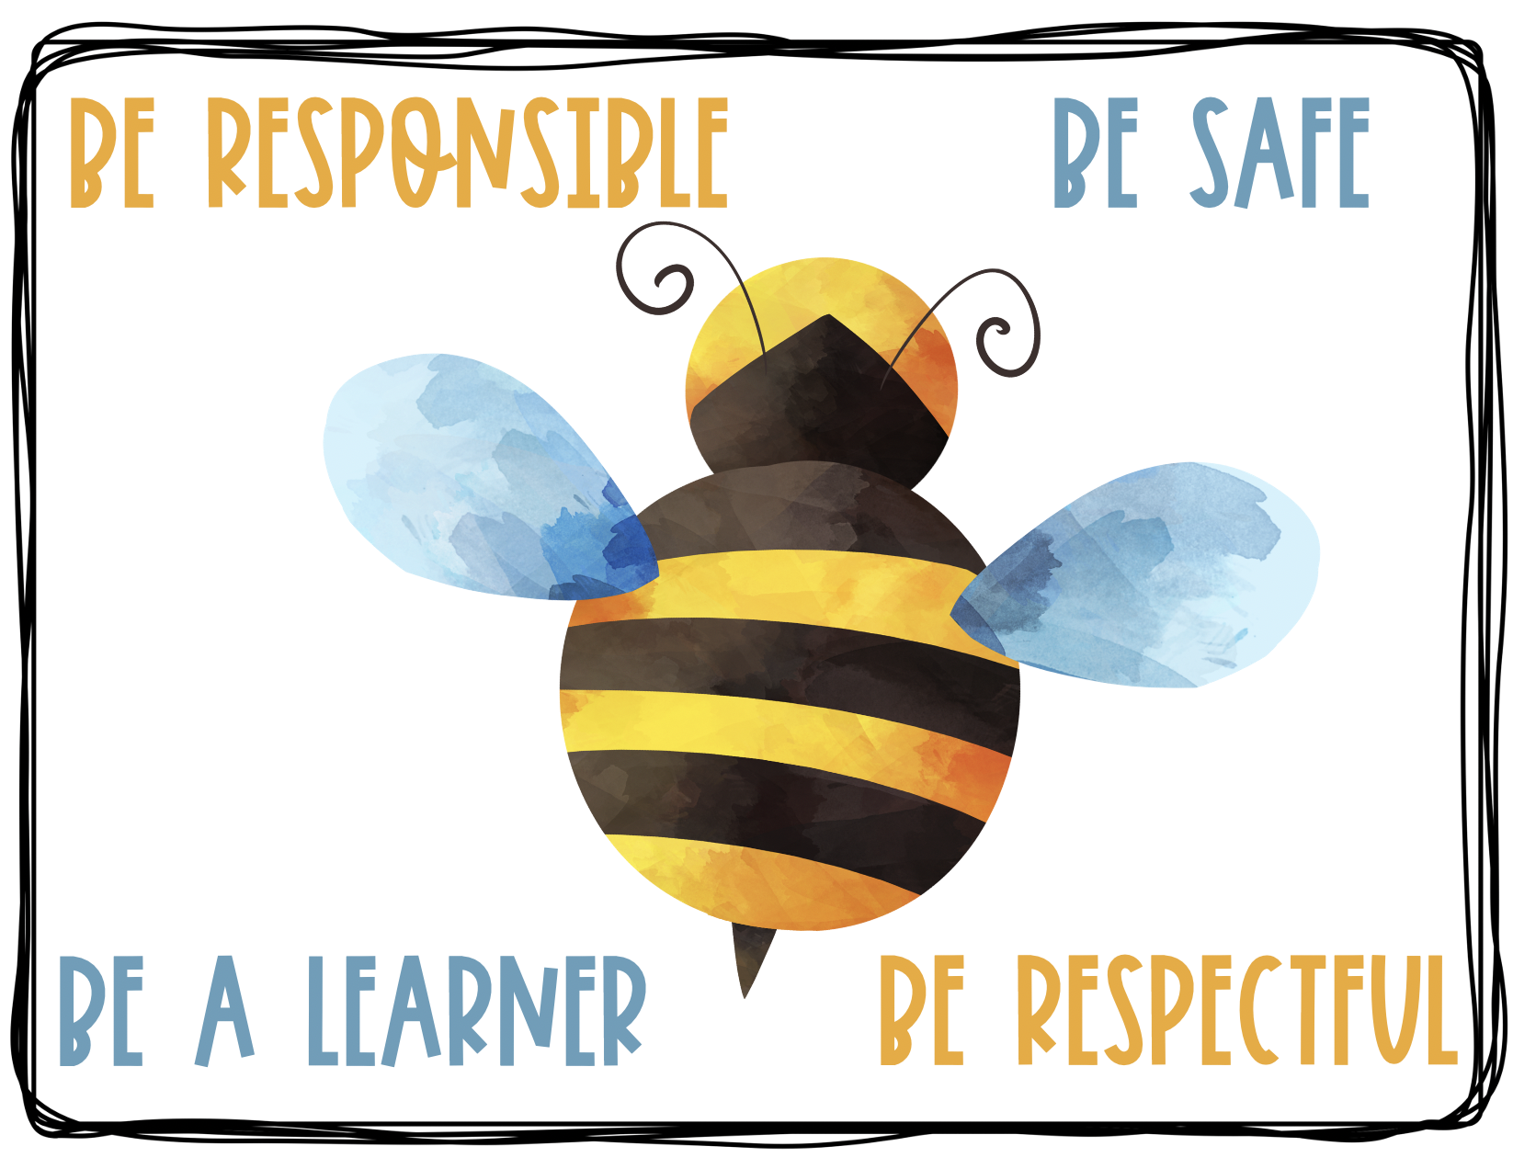

MTSS Behavior Matrix

