C:\Users\lallen\AppData\Local\Microsoft\Windows\Temporary Internet Files\Content.IE5\V4W8PXIM\MC900412732[1].wmfOrange-Peachy Smoothie

½ Quart Orange Sherbet

1 Carton of Peach Yogurt

1 12 oz. can Peach Juice

Place all ingredients into a blender and blend until smooth. Pour into glasses and serve.

Berry Blast Smoothie

1 cup Apple Juice 1 ½ cups Lemonade

1 cup Frozen Raspberries ½ cup frozen Strawberries

½ carton Vanilla Ice cream

Pour all liquid ingredients into the smoothie maker. Add all frozen ingredients. Blend at PULSE setting for 30 seconds. Then blend on ON setting until smooth. While the machine is running, move the STIR STICK around counter-clockwise to aid mixing. Serve.

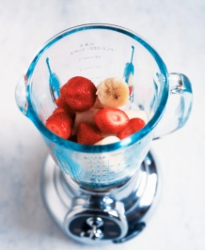Raspberry Cream Smoothie

1 1/2Cups Orange Juice 1 6 oz. raspberry yogurt

½ carton vanilla ice-cream ½-1 frozen banana(chunks)

1 ½ cup frozen Raspberries

Pour all liquid ingredients into the smoothie maker. Add all frozen ingredients. Blend at PULSE setting for 30 seconds. Then blend on ON setting until smooth. While the machine is running, move the STIR STICK around counter-clockwise to aid mixing. Serve.

Fruitie Smoothie

½ Quart Rainbow Sherbet 1 Carton Strawberry Yogurt

1 1/2 Cup Strawberry Kiwi Juice

Place all ingredients into blender and blend until smooth. Pour & Serve!